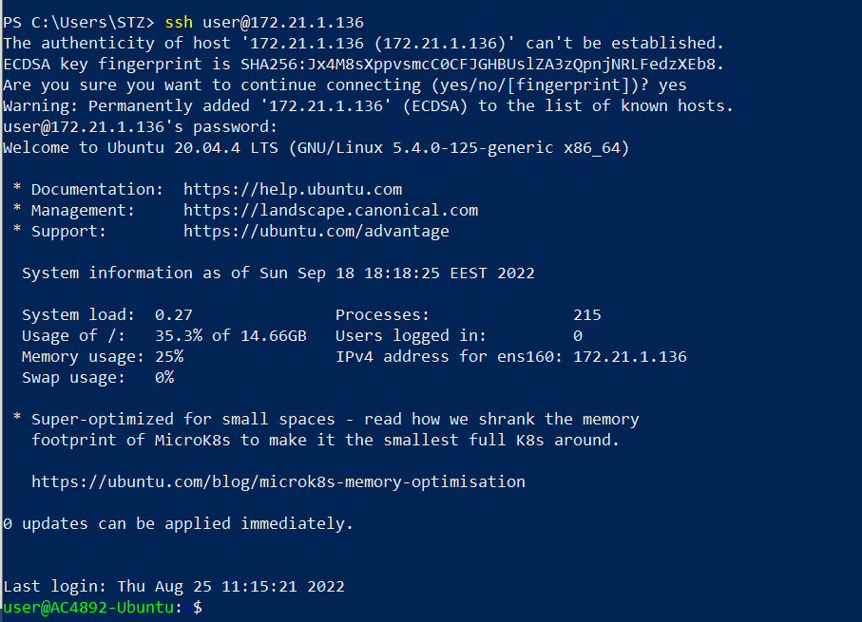

Open Powershell

Then type ssh user@172.21.7.154 (user is the username of the machine and IP is the once we create through VL Environment)

Once you press enter you need to type ‘yes’ to confirm the message

Then type password which is ‘root66’